Da Vinci Connect 2018-2019
Janette Kiso  Collabor-ative Program  Gr. K-3 | Jennifer Johnson  Collabor-ative Program  Gr. 4-8 | Kelly Ann Sassone  Hybrid Program  Core 1 (Kinder) | Darlene Wonggaew  Hybrid Program  Core 1 (Kinder) | Photo  Coming  Soon  Kelsey Grady  Hybrid Program  Core 2 (Gr. 1-2) | Photo  Coming  Soon  Julia Rivera  Hybrid Program  Core 2 (Gr. 1-2) | Megan Johnson  Hybrid Program  Core 3  (Gr. 3) | Patrick Garland  Hybrid Program  Core 4  (Gr. 4-5) | Rita Bouchard  Hybrid Program  Core 4  (Gr. 4-5) | A School for Home-schoolers
Nancy Waites  Hybrid Program  Core 5 Math  (Gr. 6-8) | Sascha Lopez  Hybrid Program  Core 5 Science  Literacy (Gr. 6-8) | Robin Brown  Hybrid Program  Core 5 Humanities  (Gr. 6-8) | Photo  Coming  Soon  Jordan Steinmann  Hybrid Program  Core 5 _______  (Gr. 6-8) | Helen Chan  Algebra Teacher | Theresa Leone  Parent Educator Support Teacher | Jennifer Vega  Inclusion  Specialist | Photo  Coming  Soon  Raphael Tangalos  Inclusion Specialist | Kené Washington  Counselor | Photo  Coming  Soon  TBD  Speech and Language Therapist
Photo  Coming  Soon  Emily Simon  Speech and Language Assistant | Allegra Johnson  Director of Special Education | Jacqueline Jimenez  School Psychologist | Photo  Coming  Soon  Emily Green  Nurse | Jim Sullivan  Maker | Brianne Allen  Operations Manager | Lynne Yoon  Office Manager | Photo  Coming  Soon  Bernadette Glenn  Office Clerk | Michelle Rainey Principal | Kaitlin Toon  Dean of Students
John Fernandez  Facilities Director | Albert Gonzalez  Facilities | Ramon Sanchez  Facilities | Jesse Corral  I.T. Director | James Py  I.T. Support | Samuel Renteria  I.T. Support | 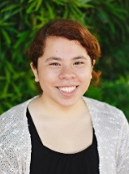  Karen Escobar  Academic Coach | 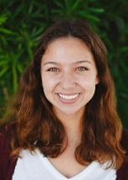  Savanah Langley  Academic Coach | Megan Breitschwerdt  Academic Coach | 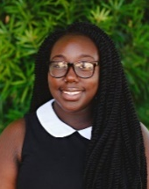Samiyah Hall  Academic Coach
Photo  Coming  Soon  Jalen Chandler  Academic Coach | Photo  Coming  Soon  Jacob Diaz  Academic Coach | Photo  Coming  Soon  Kathy Escobar  Academic Coach | Photo  Coming  Soon  Yvette Ramirez  Academic Coach | Photo  Coming  Soon  Skyler Hilacion  Academic Coach | Photo  Coming  Soon  Isaiah Kaai  Academic Coach

