**Take a Seat…**

Project Overview

Through in-class discussions and activities, students will come to understand the difference between needs and wants, as well as the definition and history of Human Rights. They will apply this knowledge to the exploration of their own multiple identities, and how each comes together to create a whole-person experience in this world.

Once students are able to understand how Human Rights plays into their world experiences, they can then look outward to create a ball pit to be initially staged at DV Exhibitions (and eventually travel to various organizations and businesses) that will require people answer questions that will bring them together based on their personal experiences with Human Rights.

**To Understand**

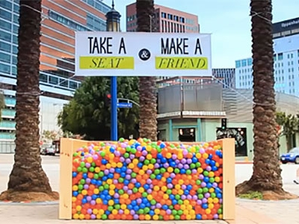

Driving Questions

What is the difference between a want and a need? What are human rights and what do they mean for me? Using Human rights that I have, how can I bring awareness to rights that might not be supported in my community? What skills do I need to successfully execute this event?

(and eventually travel to various organizations and businesses)

Deliverables

1. In pairs, you will create and facilitate an interview about Human Rights and multiple identities with at least 2 people from one of the DV high schools.
2. Individually, you must write a narrative explaining what we are learning, why it’s important, and what the interview will be used for, which you will present to each interviewee.
3. In your pair, you will analyze and reflect on the data collected on your interviews, then create ONE question to be added to the ball pit.
4. You will choose a committee to join that will have a part in organizing the event itself. You are responsible for your part of your committee’s work.

Dates

Narrative intro for interview (individual) 9/15-9/16

Completed interview (pair) 9/22-9/23

Final Question submission (pair) 9/25-9/26



Committee work-Last Day of Project 10/2-10/3

Skills/Standards

Reading Lit:

**Key ideas and details:** Read closely to determine what the text says explicitly and to make logical inferences from it; cite specific textual evidence when writing or speaking to support conclusions drawn from the text.

**Craft and Structure**: Assess how point of view or purpose shapes the content and style of a text.

Writing:

**Text Types and Purposes:** Write narratives to develop real or imagined experiences or events using effective technique, well-chosen details, and well-structured event sequences.

History:

**S.S.C.A. 6-8.** Historical Interpretation.1-6