DVIA Navigating NWEA 2015-2016_________________________________________________

- Logging in http://tinyurl.com/nnqxncm
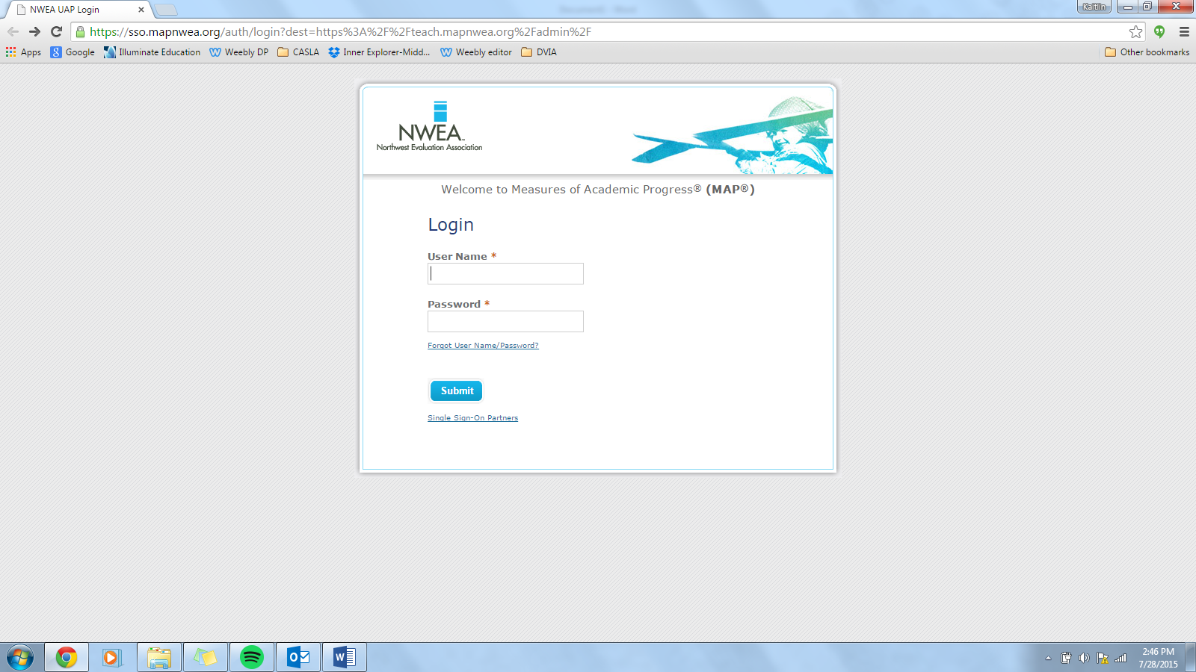
Username: dvia e-mail address

Password: Kaitlin will assign you a password that you can then change

- Creating and managing test sessions
On the left hand toolbar, you’ll click “Manage Test Sessions”
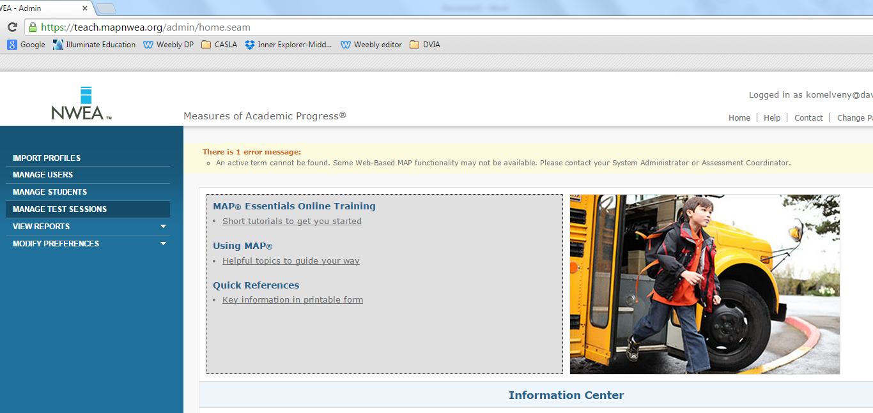
You will use this feature to create and manage test sessions for your students

2a. Creating a test session
You’ll click on “Find Students to Test” if you are only wanting to test a small group of your students

You’ll click on “Test My Class” if you are going to test your entire class. This is what I recommend, so that all students are accessible. Within this feature you can test students on either the ELA or MATH test, different grade levels, etc. I’ve found that this is the easiest method of setting up test sessions.

2b. Managing a test session
Once you’ve already created and named a test session, you can come back to that session any time within the testing window. Simply use the drop down menu to select the correct session, then click “test now” to re-activate the session

- During testing
Once the testing window is available, and you’ve created a testing session, you’ll be able to manage different aspects of the session while the test session is active. Some capabilities include:
-assigning tests for students: To assign a test, make sure students are in “awaiting student” mode
-pausing tests: To pause a test, make sure students are in “testing” mode. To un-pause, click “resume”
-suspending tests: To suspend a test, make sure students are “testing” mode. To unsuspend, click “test again”
-tracking progress of students taking a test
-Assigning additional tests for students
-ending test session (it will still be available throughout the testing window once you log off, don’t worry!)
Select status= selecting students ie all or none, Select Action= “to be confirmed”, “test again”, etc., Assign test= assigning either Math or Reading: (age band) Common Core…Or Primary Grades/Screening for kinder/1st

If something isn’t working, make sure that students are in the right “mode” for the action that you’d like to complete, then try again

4. Student Interface
-Go to www.test.mapnwea.org
-On computers, make sure to allow pop ups (upper right hand corner>box with red X in it>always allow pop ups>refresh the page)
-On ipads, make sure to enable guided access (hit home button 3 times> password is 1550> draw gray area around web link> click resume)

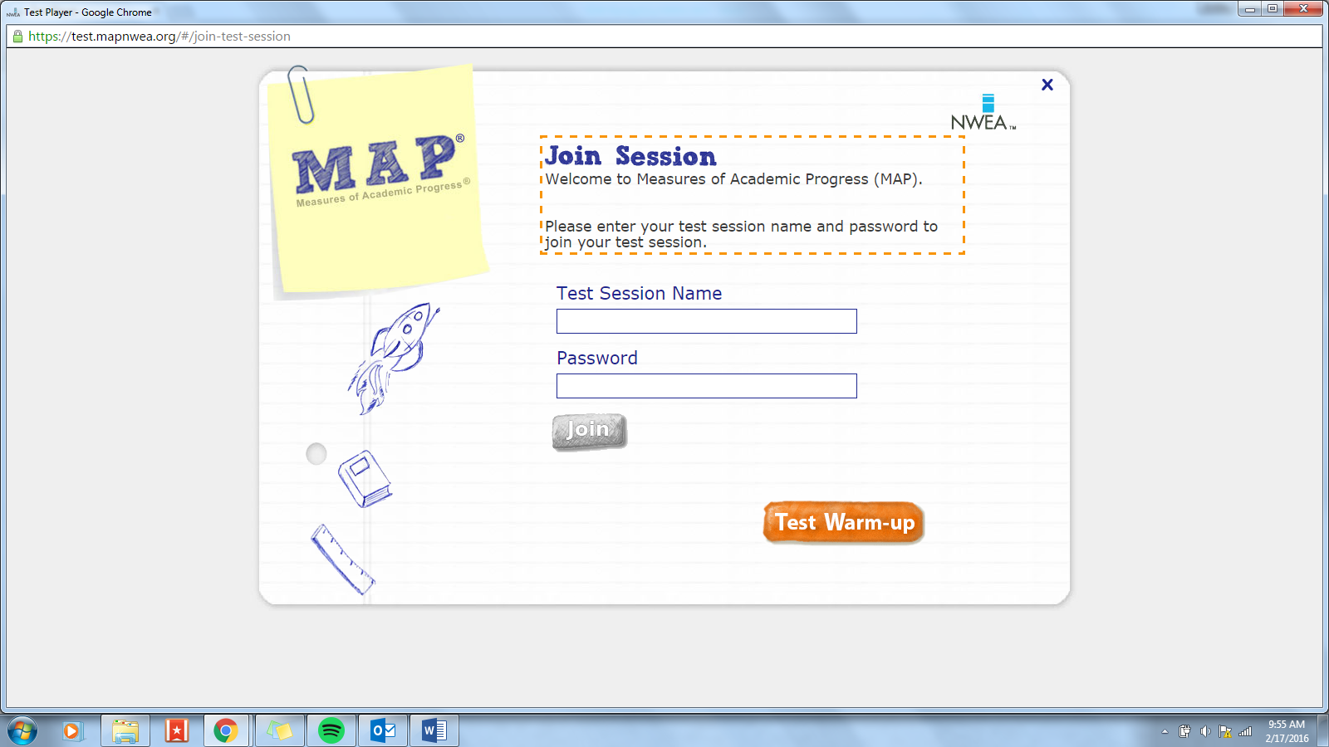
-Make sure devices are fully charged, and have access to a charging station if necessary
-Have the session name and password available on the board so students can log in
-If you’ve assigned their test already, it will already populate. If you have not assigned a test, students will need to choose their test

If a device isn’t letting a student log in, and you’ve done what you’ve needed to do on your proctor screen, refresh the page, or exit out of the program and try again (on ipads this includes disabling guided access, refreshing the page, then enabling guided access again)

5. Pulling Reports after testing
On the left hand toolbar, scroll down from the “View Reports” tab, and click on “MAP reports”

You’ll use this feature to access the data sets for individual students/your class after testing is complete

6. Types of reports to pull
If you want to pull data for all students, I recommend one of the last three options (depending on what specific data you want, and how you want it displayed)
For a single student report, I recommend using the Student quick Search
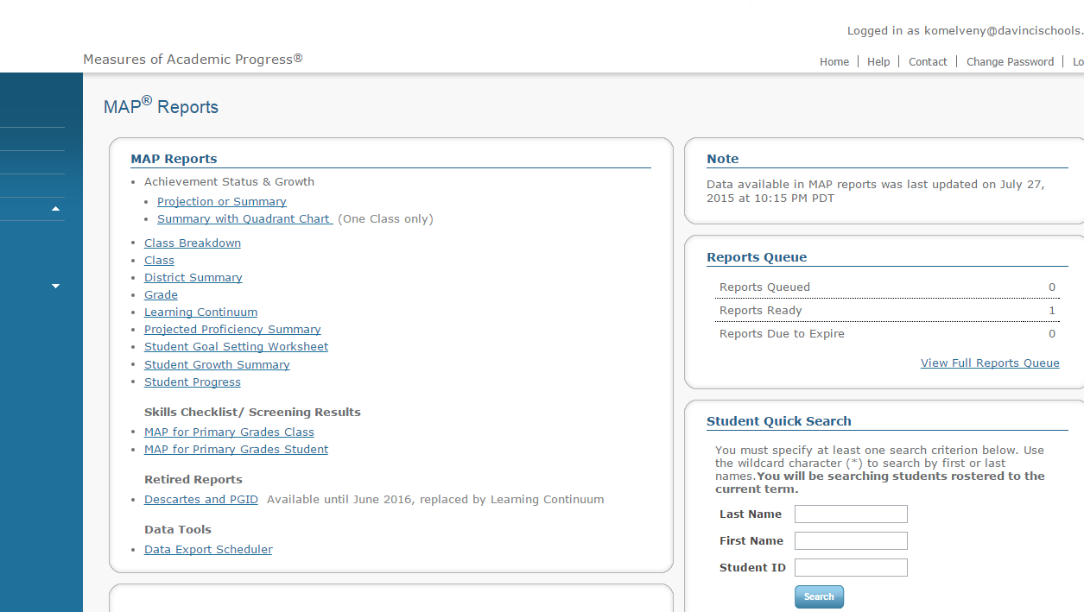

7.Supporting families in using the data for instruction
After you give and explain MAPs reports to families, they often wonder what the next steps should be. On the same page as MAP Reports, you can click on the “Descartes and PGID” icon. This will open up a resource that provides differentiated instruction ideas based on student RIT (average) scores.
